

**KESHAV MEMORIAL INSTITUTE OF TECHNOLOGY**

**PROJECT SCHOOL CERTIFICATE**

**Title                 :** Medical Visual Question Answering

**Mentor**              : Dr. Devika Rubi

**Duration**           : 3rd year 1st sem

**Name**                : MULUKUNTLA BHIKSHAPATHI

**Roll Number**    : 21BD1A059B

**Class**                 : CSE - E

**Year**                 : III - I

**Signature of Student**                                                        **Signature of Faculty**

**CONTENTS**

i. Objective…………………………………………………………..03

ii. Technical Stack…………………….………………...………......03

iii. Dataset Description………………………….……………….03-04

iv. Model Description…………………..……………….……….04-10

* Model I  (BLIP IMAGE TEXT ANSWERING  MODEL)
* Model II  (FUSION MODEL)

v. Front End Implementation…………………….……………...11-12

vii. Structure of MERN Website………………………...………….13

viii. Deployment of Model using AWS………..…..………….....13-14

ix. Screenshots………………….…………..…….…...…………16-20

ix. References………………………….……………………………20

x.Summary……………………………….………………….………21

**OBJECTIVE:**

1.Create on MERN platform.

2.Develop transformers algorithms for Medical Visual Question Answering.

3.Integrate the MERN platform and the algorithm.

4.Deploy it on Cloud.

**TECHNICAL STACK:**

1. MERN based Web platform.

2. User Authentication using MongoDB.

3. Medical Visual Question Answering Using BLIP and Fusion Model.

4. Deployment using Amazon Web Services (AWS).

**DATASET DESCRIPTION:**

**Name:** PathVQA: 30000+ Questions for Medical Visual Question Answering

**Source:** HuggingFace

**Link:**[**https://drive.google.com/drive/folders/1G2C2_FUCyYQKCkSeCRRiTTsLDvOAjFj5**](https://drive.google.com/drive/folders/1G2C2_FUCyYQKCkSeCRRiTTsLDvOAjFj5)

**Content:**

     PathVQA is a dataset of question-answer pairs on pathology images. The dataset is intended to be used for training and testing Medical Visual Question Answering (VQA) systems. The dataset includes both open-ended questions and binary "yes/no'' questions. The dataset is built from two publicly-available pathology textbooks: "Textbook of Pathology" and "Basic Pathology", and a publicly-available digital library: "Pathology Education Informational Resource'' ( PEIR ). The copyrights of images and captions belong to the publishers and authors of these two books, and the owners of the PEIR digital library. We collect 32,799 open-ended questions from 4,998 pathology images where each question is manually checked to ensure correctness. To our best knowledge, this is the first dataset for pathology VQA. Our dataset will be released publicly to promote research in medical VQA.

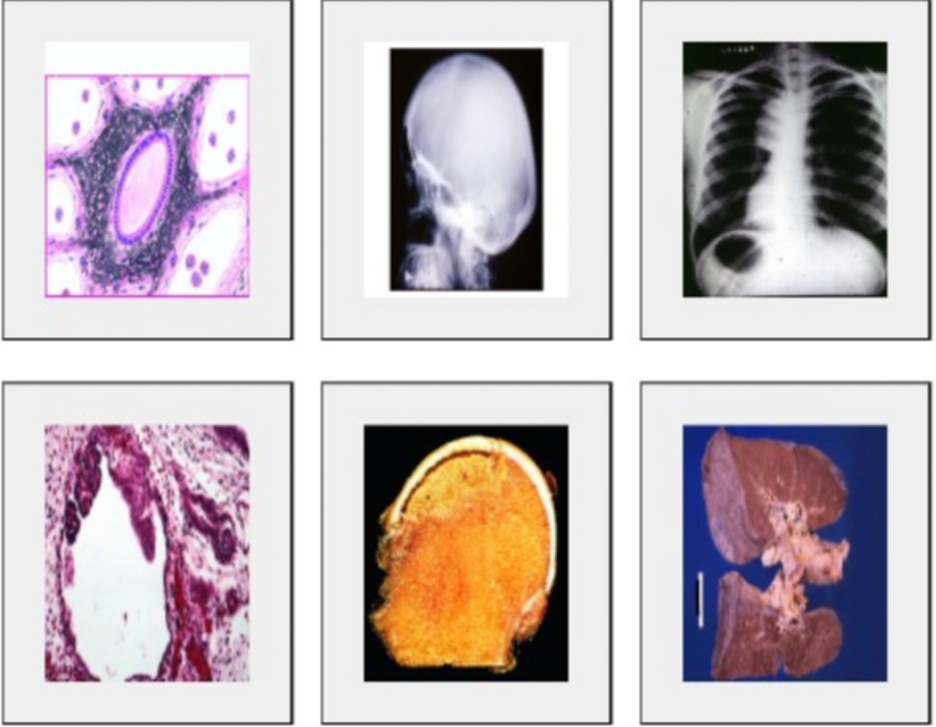

**Model Description:**

**MODEL I:**

**BLIP MODEL:**

The Salesforce/BLIP-VQA-Base model, after meticulous fine-tuning on the Path-VQA dataset tailored for medical Visual Question Answering (VQA), emerges as a powerful solution adept at comprehending and responding to queries related to medical imagery. Leveraging a transformer-based architecture, the model excels in capturing intricate contextual relationships and dependencies within medical images. Trained for high accuracy and robust performance, it navigates diverse complexities in the medical domain, providing valuable insights for healthcare professionals. With an emphasis on scalability and interoperability, this model is poised for deployment on cloud platforms, seamlessly integrating with MERN platforms to contribute to the advancement of medical visual question-answering applications.

**CONFIGURATION OF THE MODEL:**

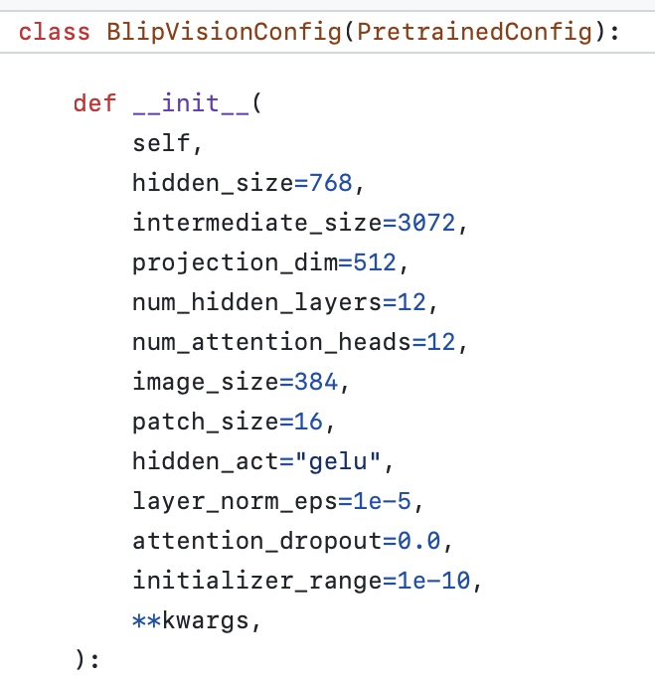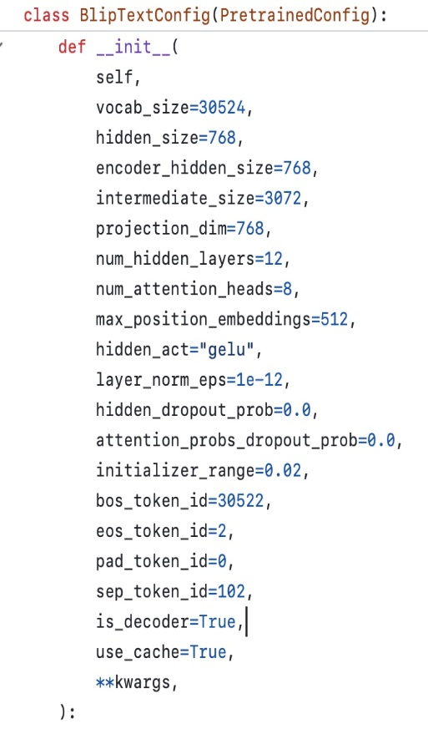  
  
  
  
  
**BLIP ARCHITECTURE (FOR VQA):**

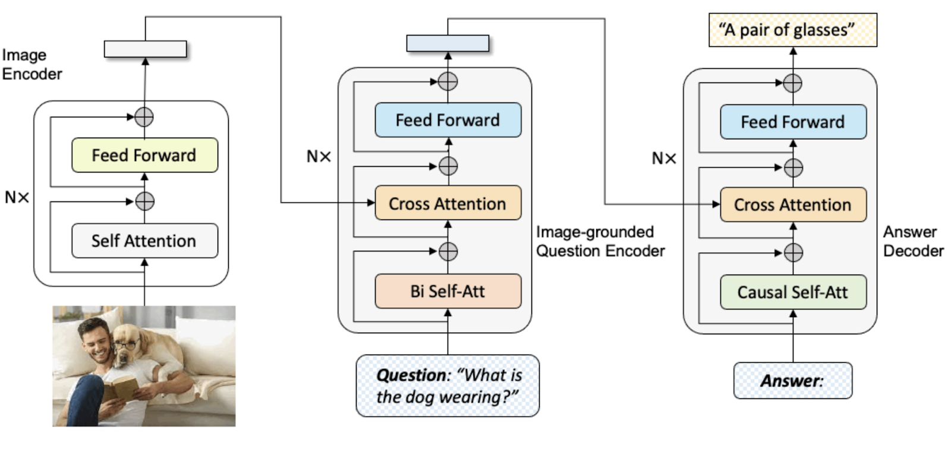

**WORKING OF MODEL**:

**Input Processing**:

* Input: The model receives an image and a corresponding question as input.

**Image Encoding**:

* The divided image patches undergo a series of transformations.
* Self-Attention Mechanism: Self-attention is applied within the patches, and this process is iterated 12 times (as specified in the model), enhancing the model's ability to capture relationships within the image.
* 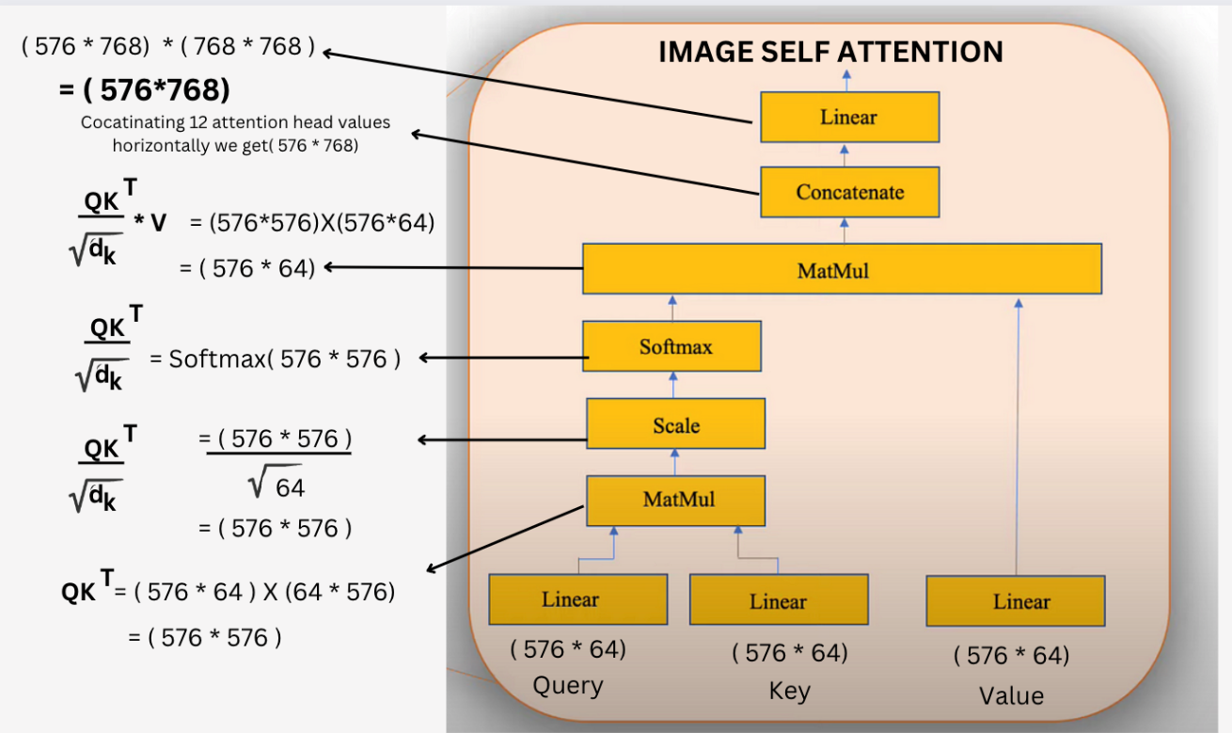Feed-Forward Processing: Each patch undergoes feed-forward processing, contributing to the overall encoding of the image.

**Text Encoding** (BERT Attention):

* The question is processed to obtain an encoded text representation.

**BERT Attention**: BERT attention is applied to the question, enabling the model to capture contextual information within the textual input.

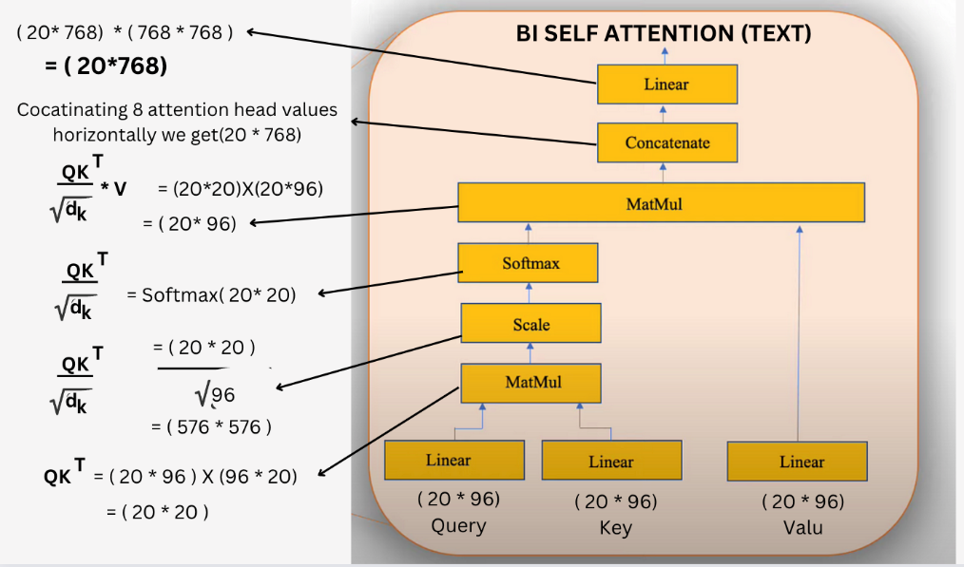

**Cross-Modal Attention**:

* Between Image and Text: The encoded image and encoded text representations are subjected to cross-modal attention, allowing the model to establish connections and capture interdependencies between visual and textual information.
* This cross-modal attention process is repeated 12 times, refining the understanding of the interactions between image and text at each iteration.

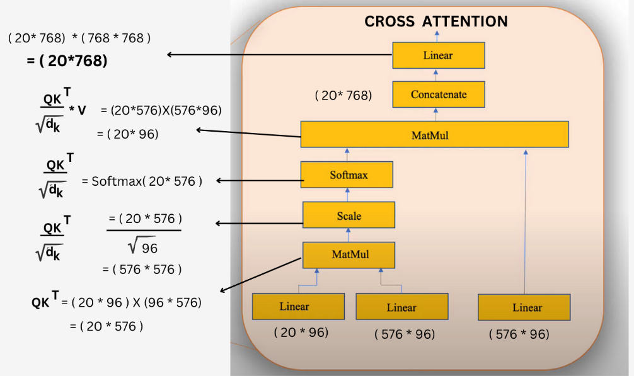

**Mixed Representation**:

* The output of the cross-modal attention becomes a mixed representation, combining the enriched information from both image and text inputs.

**Decoder Processing**:

* The mixed representation is forwarded to the decoder for further processing.

**Decoding Steps**:

* Cross Attention with BOS Tokens: Cross attention is applied between the Beginning of Sentence (BOS) tokens and the encoded mixed representation. This process is iterated 12 times.
* Token Prediction Loop: The model iteratively predicts the most probable tokens, appends them to the answer sequence, and continues this process until either the End of Sentence (EOS) token is predicted or the maximum sequence length is reached.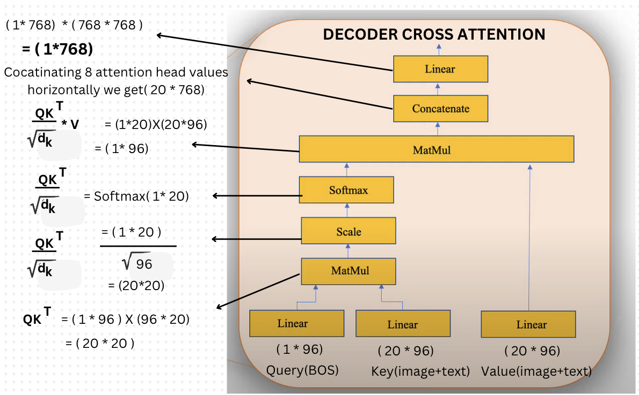

**Output**:

* The final output is the generated answer sequence, reflecting the model's understanding and response to the input image and question.

**Model II:**

**FUSION MODEL:**

VQA involves a comparison of the semantic information present in the image and the question, there is a need to jointly represent the features from both modalities. This is usually accomplished through a fusion layer that allows cross-modal interaction between image and text features to generate a fused multimodal representation.

In fusion models the information from the text and image encoders are fused into a combined representation to perform the downstream task.

In this approach, we employ 'Late Fusion.' The concept behind late fusion involves fine-tuning pretrained text and image transformer models because they are easier to train.

**FUSION ARCHITECTURE:**

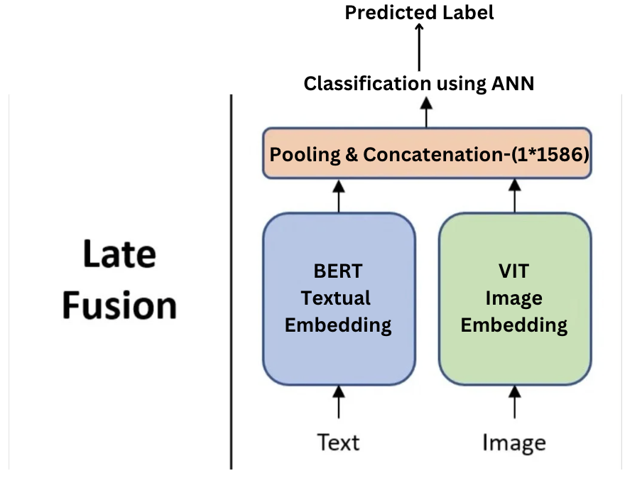

* A text transformer (BERT) to encode the question and generate embeddings
* An image transformer (ViT) to encode the image and generate features
* A reasonably simple fusion layer that concatenates the textual and image features and passes them through a linear layer to generate an intermediate output

**WORKING OF MODEL:**

**Input Processing:**

Model receives an image and corresponding question as input

* Text Processing: Preprocessing and tokenization of text are done using a pre-trained ‘BERT base-uncased’ model.
* Image Processing: The image is initially divided into patches for further analysis by using ‘google/vit-base-patch 16-224-in21k’ model.

**Text Encoding (BERT):**

* The question is processed to obtain an encoded text representation.
* BERT Attention: BERT attention is applied to the question, enabling the model to capture contextual information within the textual input.
* The output of this BERT encoder is the features (numeric values) of the question that we provided.

**Image Encoding (ViT):**

* It divides input images into fixed-size patches, linearly embeds them, and utilizes a transformer encoder to capture both local and global dependencies.
* The attention mechanism in the Vision Transformer (ViT) is a key component that enables the model to focus on relevant information within images.
* Feed-Forward Processing: Each patch undergoes feed-forward processing, contributing to the overall encoding of the image.
* The output of the ViT is the features (numeric values) of the image that we provided

**Fusion Layer:**

* In this fusion layer we fuse the features of text and image.
* In this layer we use pooler output of the text encoder and image encoder.
* This layer concatenates the pooler output from the text and image encoders, which are then passed to a linear layer to produce an intermediate output.

**Classifier:**

A classifier, which is a fully connected network with output having the dimensions equal to that of the answer-space.

VQA is represented as a multiclass classification task in our model. Thus, cross-entropy loss becomes a natural choice for the loss function to be minimized.

**Output:**

The final output is the classified answer from the answer-space, reflecting the model's understanding and response to the input image and question.

**MERN IMPLEMENTATION**

* **Initial Page**: In the website initial page presented on the screen it has only two options where if you are a new user registration is must or if the user has an account login option is present.
* **Signup Page**: If the user is new, he/she can register with Username, Gmail and Password on this page. These details will be passed to MongoDB and create a new user and add these credentials to the user database. After successful signup the user will be redirected to the OTP page.
* **OTP Page**: In the OTP page an OTP has been sent to the registered email using node mailer. After the verification the user is redirected to the login page.
* **Login Page**: The user will be asked to login. This functionality is implemented using MongoDB and React. Username and password from the user will be passed to MongoDB. If the user does not exist an error is thrown.
* **Home Page**: After successful login we see a homepage where there is a drop box to select an image and enter the question. On selecting image and question these parameters are send to Nodejs by using form-data where saving of data and these parameters are sent to the flask server from the middle-ware by encoding the image using base64, both the encoded-image and question are send to the flask in the Json format.
* **Prediction**: In the home page after entering the image and question these are sent to the middle-ware (NodeJS) using form-data.
* In the instance the image is decoded using base64 and then sent to the pretrained model with the question. The prediction is sent to the node server and from the node server it is sent to the react page.
* Prediction with all 4 different models.

**HOISTING REACT ON RENDER:**

Rendering is a crucial aspect of web development, and choosing the right rendering strategy can significantly impact the performance and user experience of a MERN (MongoDB, Express.js, React, Node.js) stack application. Server-side rendering (SSR) and client-side rendering (CSR) are two common approaches. Here's a brief explanation of why rendering is important and how it benefits MERN compared to other rendering sites.

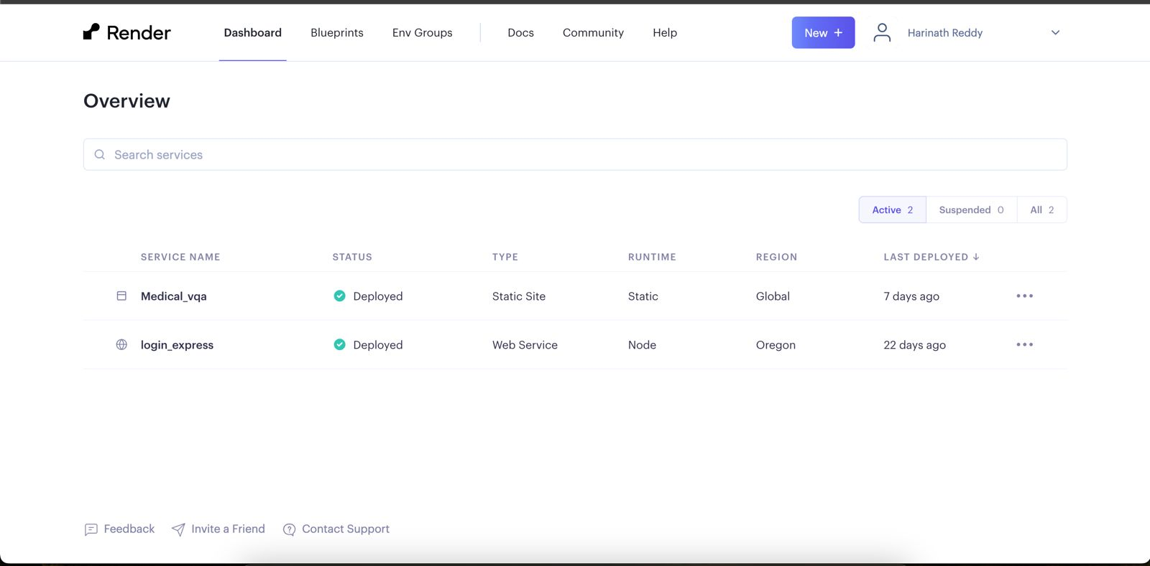

**Backend as API:**

Backend, built with Node.js and Express.js, serves as an API that handles data logic, interacts with the database (MongoDB), and exposes endpoints for frontend to consume.

This separation of concerns, with a distinct backend API, allows for a more modular and scalable architecture. It also enables potential future developments like mobile apps or other front ends to easily consume the same API.

**Frontend on Render:**

By combining a backend API with a frontend deployed on Render, we created a scalable and flexible architecture that can adapt to changing requirements. It also leverages the advantages of a cloud platform like Render for streamlined deployment and management. The Hosted Mern is available on “[**https://medicalbert.onrender.com**](https://medicalbert.onrender.com)”.

**Structure of Flask application:**

1. Import necessary modules.

2. Install required python libraries.

3. Load pre-trained models and set up necessary resources.

4. Define routes for handling incoming requests (/vpredict, /ipredict)

5. Within each route:

   - Perform any necessary validation or checks on the file or data.

   - Process the file and data.

   - Return the results to the Node server.

6. Run the Flask application in the AWS Server.

**DEPLOYMENT OF MODEL USING AWS:**

Step 1: Setting up EC2 instance in AWS Management Console.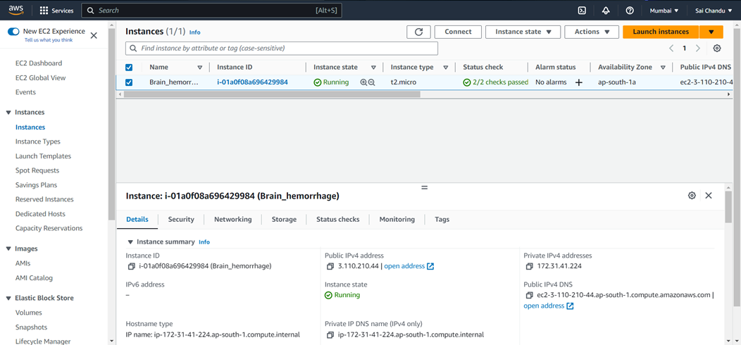

Step 2: Send the required files like model weights, flask application etc into the instance. Complete the change to be made to the security settings.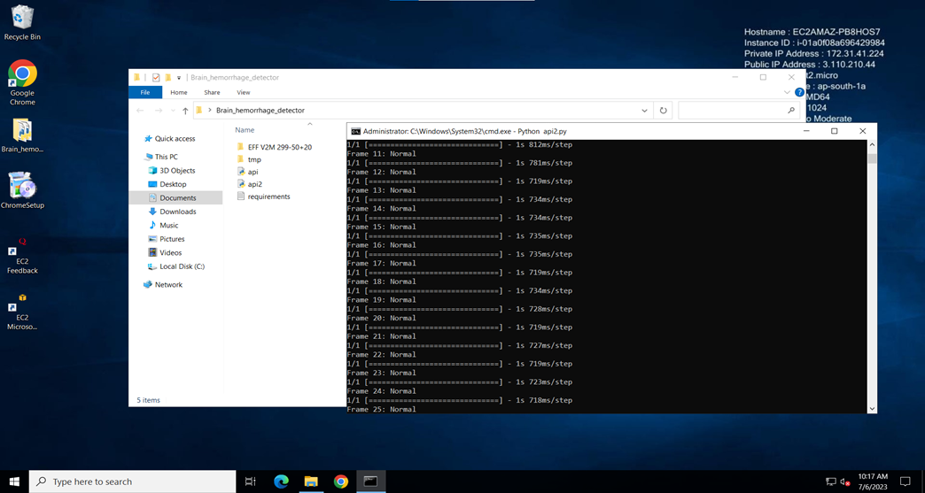

Step 3: After setting up the environment run flask code on AWS Remote Desktop using “python flask.py” on Cmd.

**Base64 Encoding:**

Base64 Image Sending:

* Usage: Base64 encoding is used when binary data (such as images) needs to be represented as a text string. This can be useful in situations where the data needs to be included in a JSON payload or transmitted through channels that only support text.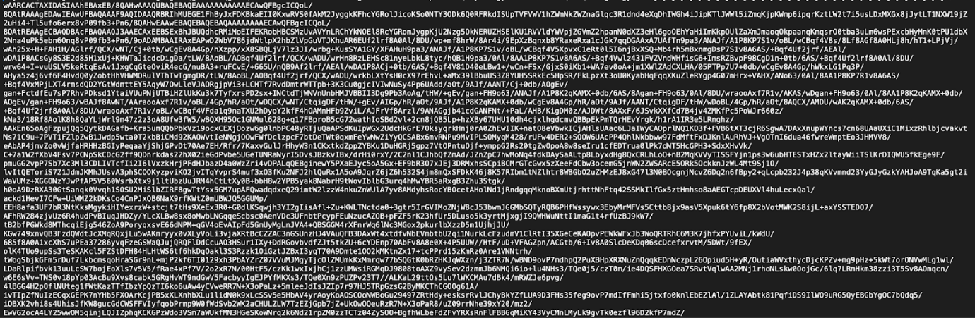

**AWS SageMaker Training:**

Amazon SageMaker Studio Lab is a free service that gives customers access to AWS compute resources, in an environment based on open-source JupyterLab. It is based on the same architecture and user interface as Amazon SageMaker Studio Classic, but with a subset of Studio Classic capabilities.

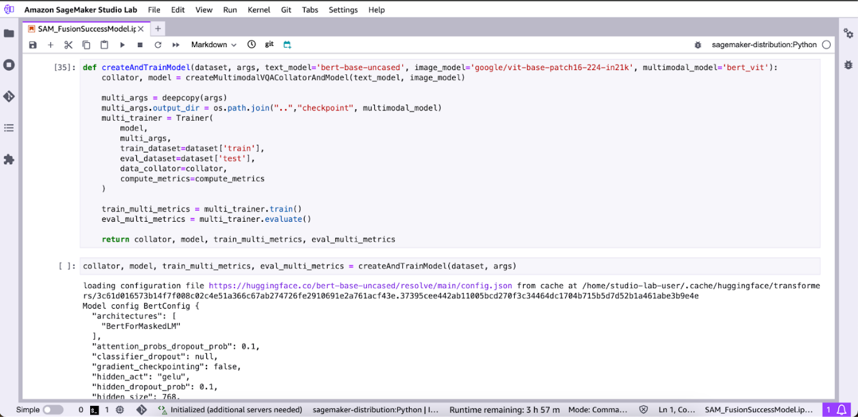

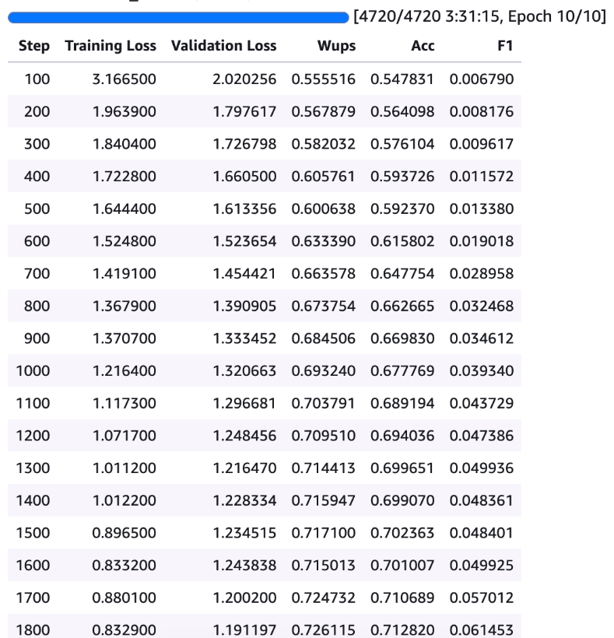  
  
  
  
**SCREENSHOTS:**

1. **Welcome page:**

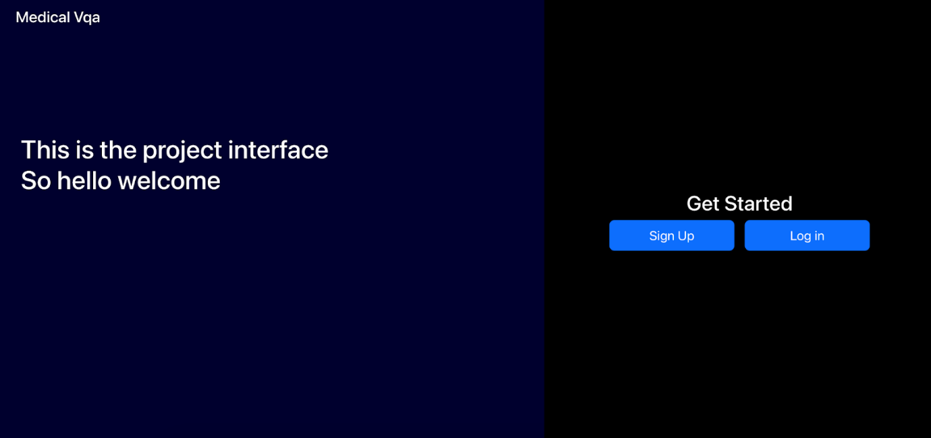

**2. Signup and Email Verification:**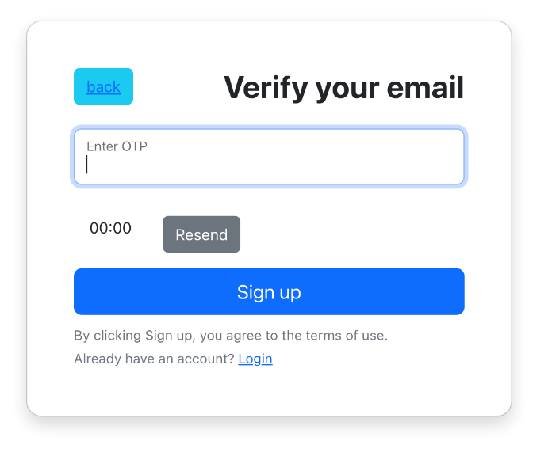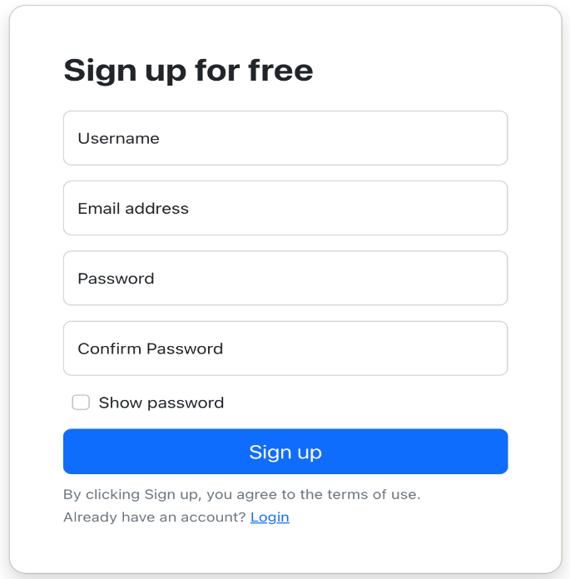

**3. Login Page:**

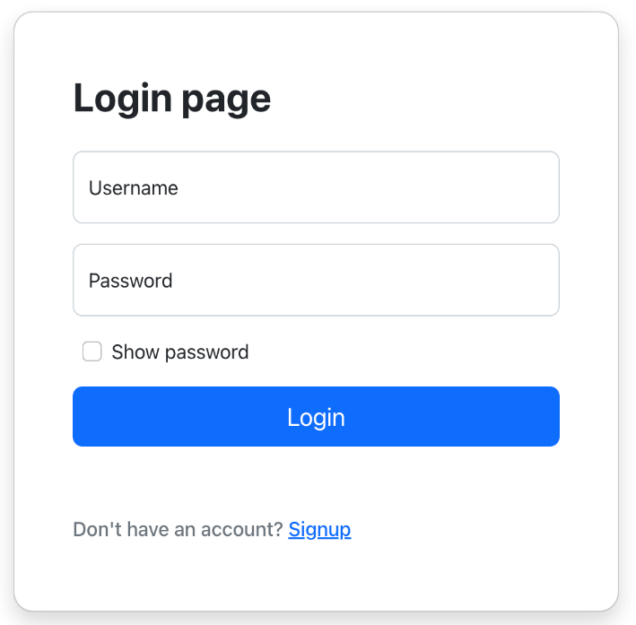

**Home Page:**

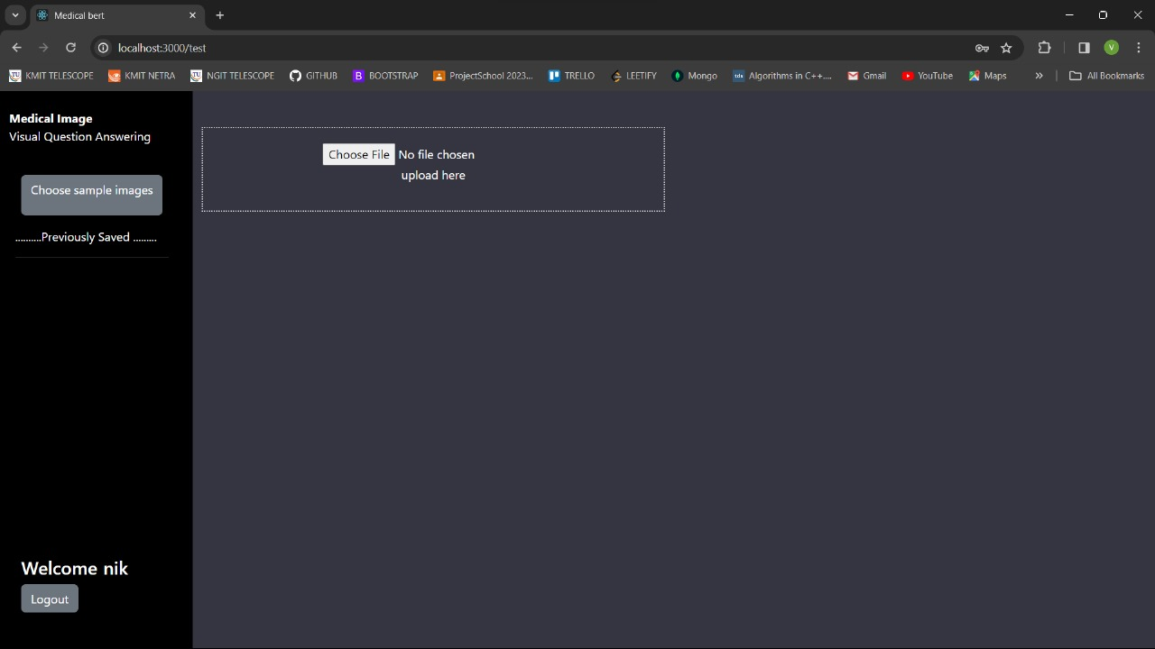

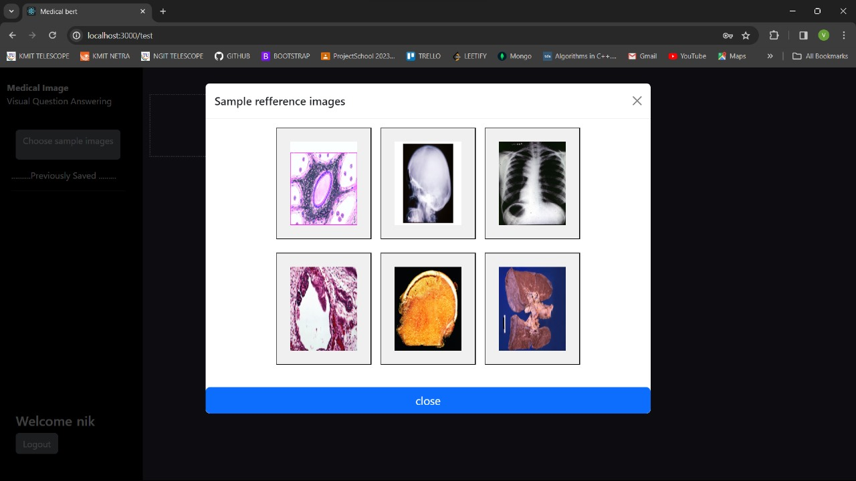

**5. Model Selection:**

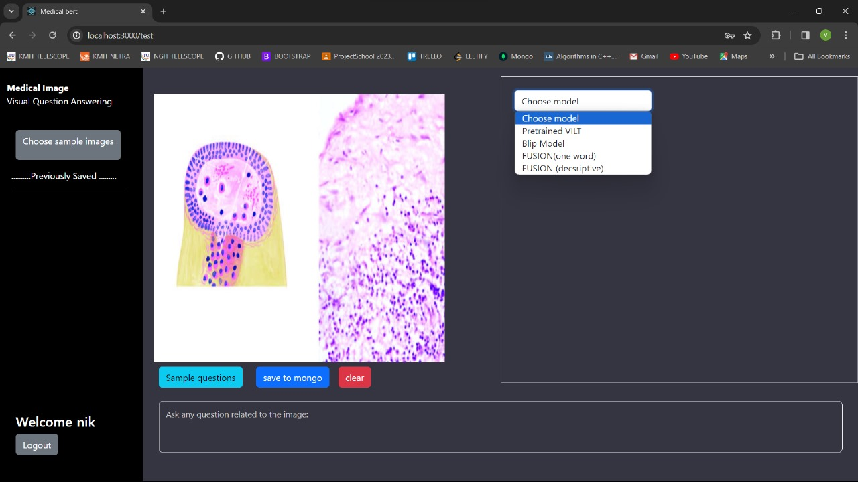

1. **BLIP Model Output:**

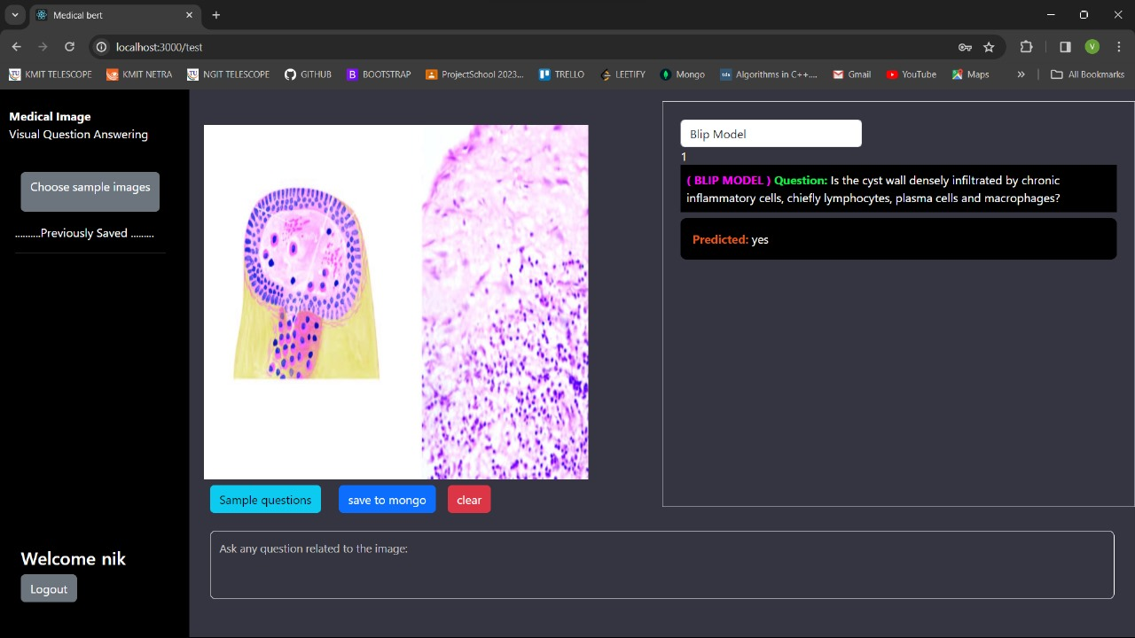

**7. Fusion one-word Model Output:**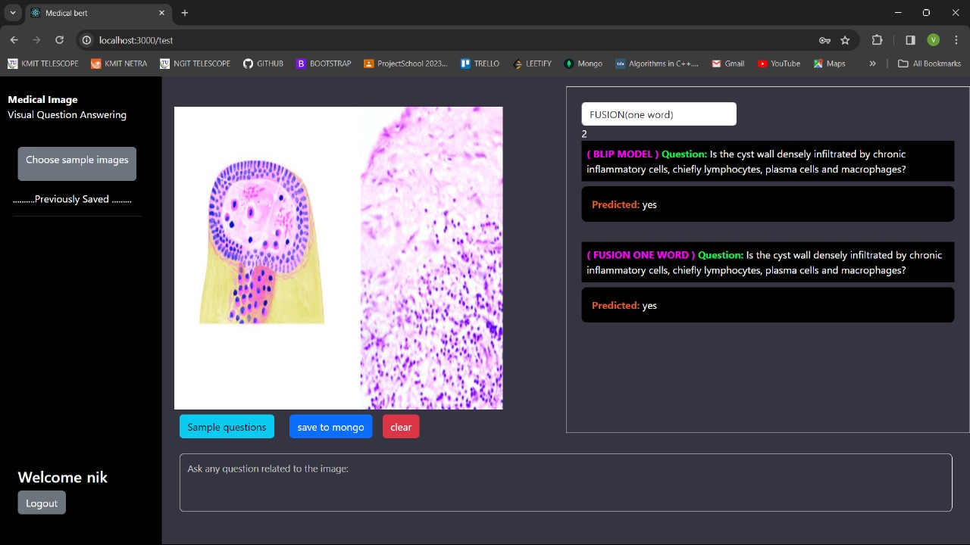

**8. Fusion Descriptive Output:**

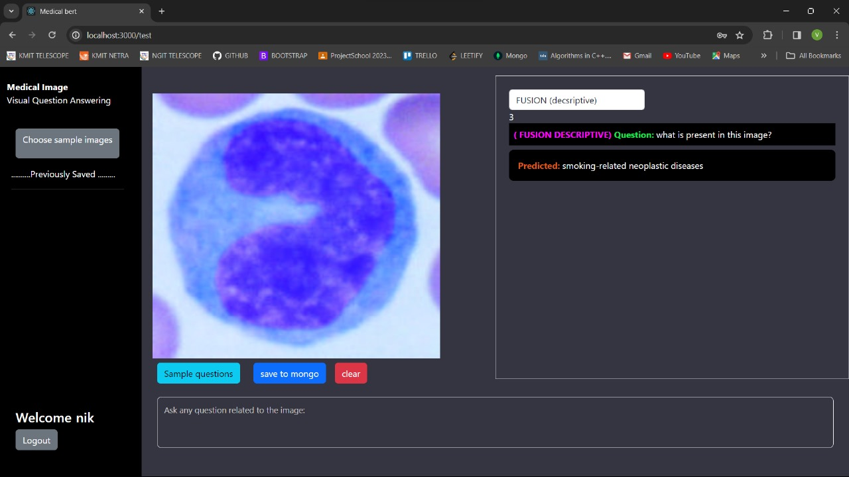

**REFERENCES:**

BLIP(Bootstrapping Language-Image Pre-training) Article -

<https://arxiv.org/pdf/2201.12086.pdf>

BLIP( GIT Code ) -

<https://github.com/huggingface/transformers/blob/main/src/transformers/models/blip>

FUSION Medium Article  -

<https://medium.com/data-science-at-microsoft/visual-question-answering-with-multimodal-transformers-d4f57950c867>

FUSION( GIT Code )  -

<https://github.com/tezansahu/VQA-With-Multimodal-Transformers>

Flask Deployment on AWS -<https://youtu.be/uhO2JvOvTWU>

Deployment of MERN -

https://www.youtube.com/watch?v=Cfi0mymfKiA

**SUMMARY:**

The successfully implemented MERN web application for Medical Visual Question Answering represents a significant stride in leveraging transformative technology for medical image analysis. This sophisticated tool is meticulously designed and deployed to accommodate the description and questioning of medical images, offering users a seamless experience through the straightforward process of uploading medical images. The application's core functionality revolves around its transformative capabilities, enabling users to not only describe intricate details within medical images but also pose pertinent questions related to the visual content.

The underlying architecture, built on the MERN stack (MongoDB, Express.js, React, Node.js), serves as a robust foundation for this endeavour. MongoDB ensures efficient data storage, Express.js facilitates the creation of a robust server-side framework, react provides a dynamic and responsive user interface, and Node.js powers the server environment, enhancing the overall performance of the application.

This innovative platform is poised to revolutionize medical image interpretation, as it empowers users to engage in a comprehensive analysis of uploaded medical images, fostering a deeper understanding of conditions and anomalies. The user-friendly interface streamlines the interaction process, making it accessible to a diverse audience, including medical professionals and researchers.

Moreover, the application's transformative capacity extends to its question-answering capabilities, allowing users to seek valuable insights and information from the uploaded medical images. By facilitating a dynamic dialogue between users and the system, the application transcends conventional boundaries, paving the way for a more interactive and informative approach to medical image interpretation.

In essence, this MERN-based web application not only embodies technological prowess but also signifies a significant contribution to the field of medical visual question-answering. Its deployment marks a notable advancement in the realm of transformative technologies, offering a powerful tool for medical professionals, researchers, and enthusiasts alike.